Updated Specifications and Results for the In Depth Assessment of North Pacific humpback whales

André E. Punt¹, Paul R. Wade², and Owen Liu¹
1: School of Aquatic and Fishery Sciences, University of Washington, Box 355020, Seattle, WA 98195-5020, USA Contact e-mail: aepunt@uw.edu
2: To come from Paul

Abstract
The 2024 assessment of the North Pacific humpback whales was based on a sex- and age-aggregated population dynamics model that can represent multiple breeding stocks, each of which may be located on multiple feeding grounds. However, this model only captured the dynamics of animals that had reached the age-at-first-parturition so assumed (incorrectly) that removals and abundance estimates applied to this population component. Thus, this paper outlines an age-structured population dynamics model for this group of whales so that catches can be assumed to be removed from the 0+ component of the population while the abundance estimates relate to 1+ abundance. The results for the four stock hypotheses are updated based on the revised model.

KEYWORDS: Humpback whales, assessment, North Pacific, mistakes, mea cupla.

INTRODUCTION
The 2024 assessment of the North Pacific humpback whales (Palka et al/, 2024) was based on a sex- and age-aggregated population dynamics model that can represent multiple breeding stocks, each of which may be located on multiple feeding grounds. The values for the parameters of this population dynamics model were estimated by fitting it to data on trends in relative and absolute abundance, and mixing rates based on mark-recapture and genetics data. The model allowed for time-variation in survival to mimic recent large changes in abundance. Results of preliminary applications of the model were created and presented for a base-case model and sensitivity scenarios, based on four stock structure hypotheses identified by the Scientific Committee.
Punt (2025) developed a revised version of this model which accounted for stochastic mortality on the age-classes between birth and reaching the age at first parturition. Basing the assessment on this revised model removed the unexpected rapid increase in predicted numbers after the end of the assessment period (which led Palka et al. (2024) to exclude the years for which a large increase in abundance occurred on plots). However, IWC (2025) noted that the model (incorrectly) assumed that removals were from the animals of the age at first parturition and older while abundance estimates (and mixing proportions) related to this component of the population.
This paper therefore extends the model on which the population dynamics of the North Pacific (and ultimately North Atlantic) humpback whales are based to be age- (but not sex-)structured so that catches can be assumed to be removed from the 0+ component of the population while the abundance estimates relate to 0+ or 1+ abundance. It then provides the results of some model runs for the revised model structure. For ease of presentation, the paper is written in the form of a set of specifications that could be included in a report of an IWC sub-committee.
THE SPECIFICATIONS
- Basic concepts: Stock and spatial structure
Two breeding stock structure hypotheses are considered. Asia, Hawaii, and Central America (Central_Am) are breeding areas in breeding stock hypotheses B1 and B2. All the whales that breed near Mexico during the winter are treated as a single stock in breeding stock hypothesis B1: including Mainland (MX_ML), the Archipiélago de Revillagigedo (MX_AR) and Baja California (MX_BJ). Whales that winter near Mexico are divided into two breeding stocks in breeding stock hypothesis B2: MX_AR and MX_ML (Table A.1). The whales found near Baja California (MX_BJ) are excluded from the B2 breeding stock hypothesis based on evidence of mixing with MX_AR and MX_ML.
There are two hypotheses regarding how the feeding grounds are combined (F1 and F2; Table A.1). These hypotheses differ in terms of where the Western Gulf of Alaska (WGOA) region is included. The WGOA is combined with the Northern Gulf of Alaska (NGOA) in feeding ground hypothesis F1 to create the Gulf of Alaska (GOA) region (WGOA+NGOA). The WGOA is combined with the eastern Aleutians (EAL) and Bering Sea (BER) to form the EAL+BER+NGOA region in feeding ground hypothesis F2.
Combining the breeding and feeding hypotheses leads to four “cases” (B1-F1, B2-F1, B1-F2, B2-F2). Table A.2 shows the presence-absence matrices for each “case”. These matrices specify the feeding grounds where animals from each breeding stock migrate to during the summer.
Table A.1. Regions and their abbreviations. Descriptions use stratum names from some previous papers as a reference. See Fig. A.1 for the locations of the regions.

Region (Abbreviation) | Description | Option
Breeding Stock
Asia (AS) | The Asian breeding region is the total of the following spatial strata as defined in Fig. A.1: “All Asia” (Philippines and Okinawa), “Japan” (Yellow Sea, Japan Sea, and around Japan), Ogasawara, and the Marianas regions | B1, B2
Hawaii (HI) | Around the Hawaiian Islands | B1, B2
Mainland Mexico (MX_ML) | The main breeding ground is off the mainland from Mazatlán (Sinaloa) to Colima, including Bahía de Banderas (Nayarit/Jalisco) and the Tres Marías Islands and Isla Isabel. | B2
Mexico Offshore Revillagigedo Archipelago (MX_AR) | Revillagigedo Archipelago is a main breeding ground and, to a lesser extent, the Baja California Peninsula and Bahía de Banderas  (Nayarit and Jalisco). | B2
Mexico | MX_ML MX_AR, and MX_BJ combined | B1
Southern Mexico to Central America (Central_Am) | From southern Mexico (Michoacan, Guerrero, Oaxaca and Chiapas) to Central America (Guatemala to Panama). Humpbacks also travel along a migratory corridor through Colima, Bahía de Banderas (Nayarit/Jalisco), and Baja California Sur. | B1, B2
Breeding/Feeding/Migratory Region
Baja California Mexico (MX_BJ) | Waters off the coast of Baja California Sur in the Baja California Peninsula (MX_BJ) is used by the two Mexican breeding regions (MX_ML and MX_AR) and by the Central_Am breeding group to feed and migrate to more northern waters.
Feeding Grounds
Russia and Western Aleutians  (RUS+WAL) | Includes Kamchatka, the Gulf of Anadyr, the Commander Islands,  and the Western Aleutians | F1, F2
Eastern Aleutians and Bering Sea (EAL+BER) | The Eastern Aleutians and Bering Sea | F1
Gulf of Alaska (GOA) = WGOA+NGOA | The Western Gulf of Alaska (WGOA) and the Northern Gulf of  Alaska (NGOA) | F1
Eastern Aleutians, Bering Sea and Western Gulf of Alaska (EAL+BER+WGOA) | The Eastern Aleutians, Bering Sea, and Western Gulf of Alaska | F2
Northern Gulf of Alaska (NGOA) | The Northern Gulf of Alaska | F2
Southeast Alaska to Northern British Columbia (SEA+NBC) | Southeast Alaska and Northern British Columbia | F1, F2
Southern British Columbia and Washington (SBC+WA) | Southern British Columbia and Washington | F1, F2
Oregon and California (OR+CA) | Oregon and California | F1, F2

Table A.2. Presence / absence matrices for the stock and spatial scenarios.
B1-F1 | Feeding ground |  |  |  |  | Breeding stock
RUS + WAL | EAL+BER | GOA | SEA+NBC | SBC+WA | OR+CA
Yes | Yes | - | - | - | - | Asia
Yes | Yes | Yes | Yes | Yes | - | Hawaii
Yes | Yes | Yes | Yes | Yes | Yes | Mexico
- | - | - | - | Yes | Yes | Central America
B1-F2
RUS + WAL | EAL+BER+WGOA | NGOA | SEA+NBC | SBC+WA | OR+CA
Yes | Yes | - | - | - | - | Asia
Yes | Yes | Yes | Yes | Yes | - | Hawaii
Yes | Yes | Yes | Yes | Yes | Yes | Mexico
- | - | - | - | Yes | Yes | Central America
B2-F1
RUS + WAL | EAL+BER | GOA | SEA+NBC | SBC+WA | OR+CA
Yes | Yes | - | - | - | - | Asia
Yes | Yes | Yes | Yes | Yes | - | Hawaii
Yes | Yes | Yes | Yes | Yes | Yes | MX_AR
Yes | Yes | Yes | Yes | Yes | Yes | MX_ML
- | - | - | - | Yes | Yes | Central America
B2-F2
RUS + WAL | EAL+BER+WGOA | NGOA | SEA+NBC | SBC+WA | OR+CA
Yes | Yes | - | - | - | - | Asia
Yes | Yes | Yes | Yes | Yes | - | Hawaii
Yes | Yes | Yes | Yes | Yes | Yes | MX_AR
Yes | Yes | Yes | Yes | Yes | Yes | MX_ML
- | - | - | - | Yes | Yes | Central America

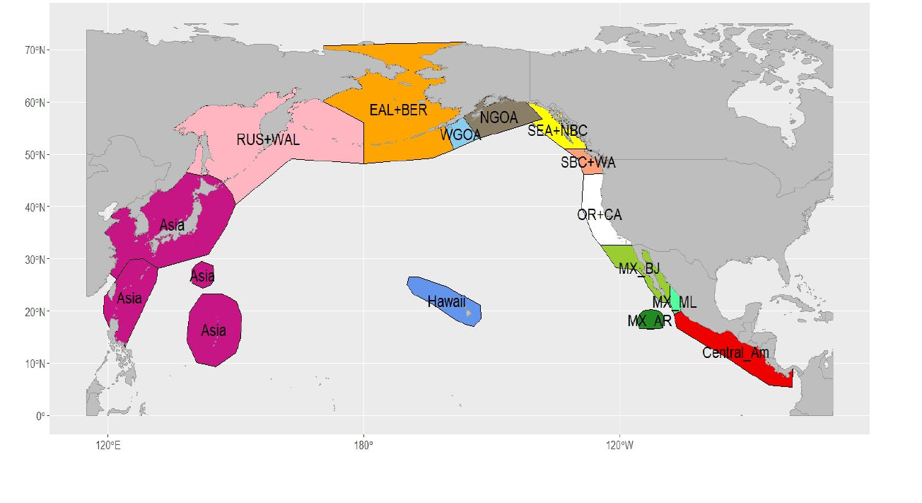
Fig. A.1. Boundaries for the breeding and feeding areas.

- Population dynamics model
B.1 Population dynamics model for the base-case model
The framework for conducting the assessment for the North Pacific humpback whales is based on an age-structured population dynamics model that accounts for multiple breeding stocks. Animals from each breeding stock are found during the summer on some of the feeding grounds (Table A.2). Each breeding stock is modelled as a ‘herd’ so that animals of a given breeding stock that feed in a given feeding ground have fidelity to that feeding ground (although the model includes the ability to account for straying of animals among feeding grounds (see Section B.2), but this does not form part of the assumptions of the base-case model).
The population dynamics are based on the following equation:

$N_{y+1,a}^{b,f}=\left\{\begin{matrix}B_{y+1}^{b,f} \\ {\tilde{N}}_{y,a-1}^{b,f}S_{y,a-1}^{b,f} \\ {\tilde{N}}_{y,x-1}^{b,f}S_{y,x-1}^{b,f}+{\tilde{N}}_{y,x}^{b,f}{ S}_{y,x}^{b,f}\end{matrix}\right.$ $\begin{matrix}if a=0 \\ if 0<a<x \\ if a=x \end{matrix}$ (B.1)

where $N_{y,a}^{b,f}$ is the number, at the start of year y, of breeding stock b animals of age a that feed in feeding ground f, $S_{y,a}^{b,f}$ is the survival rate for breeding stock b animals of age a on feeding ground f during year y, ${\tilde{N}}_{y,a}^{b,f}$ is the number of breeding stock b animals of age a that feed in feeding ground f after all of the removals during year y:
${\tilde{N}}_{y,a}^{b,f}$=${\tilde{\tilde{N}}}_{y,a}^{b,f}\left({\tilde{\tilde{N}}}_{y,0+}^{f}-C_{y}^{f}\right)/{\tilde{\tilde{N}}}_{y,0+}^{f}$ (B.2)
where$C_{y}^{f}$ is the number of removals due to direct removals and bycatches / ship strikes from feeding ground f during year y (assumed to animals of age 0 and older; see Adjunct 1 of Palka et al., 2024), ${\tilde{\tilde{N}}}_{y,0+}^{b,f}$ is the number of breeding stock b animals in feeding ground f after the breeding ground removals during year y (${\tilde{\tilde{N}}}_{y,0+}^{f}=\sum_{b}{\sum_{a}{{\tilde{\tilde{N}}}_{y,a}^{b,f}}}$):

${\tilde{\tilde{N}}}_{y,a}^{b,f}=N_{y,a}^{b,f}\left(N_{y,0+}^{b}-C_{y}^{b}\right)/N_{y,0+}^{b}$ (B.3)
$C_{y}^{b}$ is the number of removals due to direct removals and bycatches / ship strikes from breeding ground b during year y (see Adjunct 1 of Palka et al., 2024), $N_{y,0+}^{b}$ is the total number of breeding stock b animals at the start of year y ($N_{y,0+}^{b}=\sum_{b}{\sum_{a}{N_{y,a}^{b,f}}}$).
Fecundity is assumed to be a function of the density on each feeding ground so the number of births for breeding stock b animals that feed in feeding ground f during year y is:
$B_{y}^{b,f}={0.5 f}_{y}^{f}B_{y}^{b,f,*}$ (B.4)
where $f_{y}^{f}$is the fecundity for animals on feeding ground f during year y,
$f_{y}^{f}=f_{0}-(f_{max}-f_{0})(1-\frac{N_{y,1+}^{f}}{K_{1+}^{f}})$) (B.5)
where f₀ is fecundity at carrying capacity, f_{max} is fecundity in the limit of zero population size, and $K_{1+}^{f}$ is the carrying capacity for feeding ground f in terms of 1+ abundance, and $N_{y,1+}^{f}=\sum_{b}{\sum_{a>0}{{\tilde{\tilde{N}}}_{y,a}^{b,f}}}$. The value f₀ is determined from Eqn B.1 at unfished equilibrium, and f_{max} is determined from the Lokta equation given a value for the maximum rate of increase r_{max}, i.e.:
$f_{max}=({\left(1+r_{max}\right)}^{L+1}-S{\left(1+r_{max}\right)}^{L})/$( $S^{L}S_{C})$ (B.6)
where L is the age-at-maturity, $S_{C}$ is calf survival in the absence of environmental perturbations, and S is the base-case value for survival across all breeding stocks, feeding grounds, and years. The number of breeding animals is determined by one of three options:
$B_{y}^{b,f,*}=\left\{\begin{aligned}\sum_{a>L}{N_{y,a}^{b,f}} \\ {}^{b,f}\sum_{f}{\sum_{a>L}{N_{y,a}^{b,f}}} \\ 0.5\left(\sum_{a>L}{N_{y,a}^{b,f}}+{}^{b,f}\sum_{f}{\sum_{a>L}{N_{y,a}^{b,f}}}\right)\end{aligned}\right.$ $\begin{matrix}\text{Baseline } \\ \text{Alternative 1} \\ \text{Alternative 2}\end{matrix}$ $\begin{matrix}(B.7a) \\ (B.7b) \\ (B.7c)\end{matrix}$

where ${}^{b,f}$is the proportion of animals from breeding stock b that recruit to feeding ground f.
Annual survival for animals on feeding ground f is given by:
$S_{y,a}^{b,f}=\left\{\begin{aligned}\frac{1}{1+exp\left({}_{C}+{}_{y}^{f}{}_{S}\right)} \\ \frac{1}{1+exp\left({}_{A}+{}_{y}^{f}{}_{S}\right)}\end{aligned}\right.$ (B.8a)
${}_{C}=\ln\left(\frac{1}{S_{C}}-1\right);$ ${}_{A}=ln⁡\left(1/S-1\right)$` (B.8b)
where ${}_{y}^{f}$ is the deviation in survival for feeding ground f during year y, and ${}_{S}$ determines the inter-annual variability in S.
The initial conditions for each herd are based on the total 1+ abundance at the start of the first modelled year and the assumption that the population was in equilibrium given S_{C} and S.
B.2 Specifications for sensitivity tests
Most of the sensitivity tests involve changes to the values of the parameters of the population dynamics or observation models (see Section D.2). An exception to this is how modelling of straying among feeding grounds within breeding stocks is implemented. The number of animals of breeding stock b on feeding group f straying to feeding ground f’=f-1 (where the order of feeding grounds matches their geographic order), ${\tilde{\tilde{N}}}_{y,a}^{,Stray,b,f,f'},$ depends on the relative depletion of feeding grounds f and f-1. Straying is assumed to occur after any breeding ground catches but before any feeding ground catches, i.e.:
${\tilde{\tilde{N}}}_{y,a}^{,Stray,b,f,f'}={\tilde{\tilde{ N}}}_{y,a}^{b,f}\left(\frac{(R_{y}^{b,f,f^{'}}-1)}{1+exp\left(-100\left(R_{y}^{b,f,f^{'}}-1\right)\right)}\frac{1}{1+exp\left(100\left(R_{y}^{b,f,f^{'}}-2\right)\right)}+\frac{1}{1+exp\left(-100\left(R_{y}^{b,f,f^{'}}-2\right)\right)}\right)$ (B.9)
where β is straying rate (0 for the base-case model), and $R_{y}^{b,f,f^{'}}$ is the relative depletion ratio:
$R_{y}^{b,f,f^{'}}=\left({\tilde{\tilde{N}}}_{y,1+}^{b,f}/K^{f}\right)/\left({\tilde{\tilde{N}}}_{y,1+}^{b,f'}/K^{f'}\right)$ (B.10)
- Model parametrization and fitting
C.1 Model parameterization
The estimable parameters of the population dynamics model (Table C.1) are the maximum rate of growth (r_{max}), the carrying capacity of each breeding stock (K^{b}, estimated in log-space), the relative depletion of each breeding stock at the start of modelled period (base-case model 1970, estimated in log-space), the parameters that determine how much of each breeding stock migrates to each feeding ground at carrying capacity (i.e., the parameters of the “mixing matrix”, δ - the entries of the matrix δ are zero for breeding stock-feeding ground combinations for which the data (or a priori assumptions) indicate that no animals of a breeding stock occur in that feeding ground - Table A.2), and the parameters that determine how much survival deviates from S / $S_{C}$ (${}_{y}^{f}$ ).Note that the number of estimated mixing matrix entries for each breeding stock is one less than the number of feeding grounds it is assumed to feed in given the constraint $\sum_{f}{{}_{}^{b,f}}=1$. Some of the sampling coefficients of variation appear to be very low so it is possible to estimate an “additional variance” parameter for the associated time-series of abundance estimates and indices. The estimable parameters of the observation model are therefore the additional variance parameters for three of the time-series of abundance estimates (the estimates of absolute abundance for the SBC+WA and OR+CA feeding grounds and the relative index of abundance for the GOA feeding ground).

Table C.1 List of parameters. The number in parenthesis is the number of estimated parameters for the base-case application of the model.

Parameter | Treatment
r_{max,} the maximum rate of growth | Estimated (1)
Ln K^{b}, carrying capacity of each breeding stock | Estimated (4)
$N_{1970}^{b}/K^{b}$, relative depletion of each breeding stock at the start of modelled period | Estimated (one for each breeding stock) (4)
${}_{}^{b,f}$, the parameters of the “mixing matrix” | Estimated (how many mixing matrix parameters depends on how many feeding grounds there are for each breeding stock) (11)
τ, “Additional variance” parameters | Estimated for the SBC+WA, OR+CA relative abundance indices and the GOA absolute abundance estimates (3)
${}_{y}^{f},$the parameters that determine how much survival deviates from S | Estimated - one parameter for each year for the feeding grounds for which there are survival deviates (96)
S_{C}, Calf survival rate for years with no survival deviates | Pre-specified – base-case: 0.8
S, 1+ survival rate for years with no survival deviates | Pre-specified – base-case: 0.96
L, Age-at-maturity | Pre-specified – base-case: 8 years
${}_{S}^{}$, extent of variation in the survival deviations | Pre-specified – base-case: 6
C.2 Objective function
The objective function minimized to find the estimates of the parameters of the model involves four types of data (in addition to a penalty on how much survival can vary from its base-case value and small penalties to assist with convergence): (a) estimates of absolute abundance, (b) indices of relative abundance, (c) estimates of the proportion of the animals on a feeding ground that come from each breeding ground, and (d) estimates of the proportion of a breeding stock that migrates to each feeding ground.
C.2.1 Likelihood components
The contribution of the estimates of absolute abundance for feeding ground f (Section A of Adjunct 2 of Palka et al., 2024) to the negative of the log-likelihood function is:
$-lnL=\sum_{y}{\left(ln{\tilde{}}_{y}+{\frac{1}{2{\tilde{}}_{y}^{2}}\left(lnN_{y}^{Obs,f}-lnN_{y,1+}^{f}\right)}^{2}\right)}$ (C.1)
where $N_{y}^{Obs,f}$ is the abundance estimate for feeding ground y during year y, ${\tilde{}}_{y}$ is the assumed standard error of the logarithm of $N_{y}^{Obs,f}$ (${\tilde{}}_{y}= \sqrt{{CV}_{y}^{2}+{}^{2}}$ where ${CV}_{y}^{}$ is the CV of $N_{y}^{Obs,f}$ and ${}_{}^{2}$ is the additional variance), and $N_{y,1+}^{f}=\sum_{b}{\sum_{a>0}{N_{y,a}^{b,f}}}$. Eqn C.1 is extended naturally when the abundance estimates relates to 0+ abundance and for the estimates of absolute abundance by breeding ground and the estimates of abundance for entire North Pacific. The contribution of the estimates of relative abundance for feeding ground f (Section B of Adjunct 2 of Palka et al., 2024) to the negative log-likelihood is:
$-lnL=\sum_{y}{\left(ln{\tilde{}}_{y}+{\frac{1}{2{\tilde{}}_{y}^{2}}\left(lnN_{y}^{Obs,f}-ln{(qN}_{y,1+}^{f})\right)}^{2}\right)}$ (C.2)
where q is the constant of proportionality (survey bias). The values for the q parameters are obtained analytically given Eqn C.2.
The contribution of the mixing data (Section C of Adjunct 2 of Palka et al., 2024) depends on whether these data are the proportion of each breeding stock that migrates to each feeding ground or the proportion that each breeding stock makes up of each feeding ground. These data are assumed to be multinomial. For the case of data by breeding stock on the split to feeding ground:
$-lnL=\sum_{b}{{}_{y*}^{b}\sum_{f}{{}_{y*}^{Obs,b,f}ln⁡({}_{y*}^{,b,f}/{}_{y*}^{Obs,b,f})}}$ (C.3)
where ${}_{y*}^{Obs,b,f}$ is the observed proportion of breeding stock b animals that migrate to feeding ground f during year y*, ${}_{y*}^{b,f}$ is the model-predicted proportion of breeding stock b animals that migrate to feeding ground f during year y*, i.e.:
${}_{y}^{b,f}=N_{y,1+}^{b,f}/N_{y,1+}^{b}$ (C.4)
${}_{y*}^{b}$ is the effective sample size for breeding stock b. The value of ${}_{y*}^{b}$ is set based on the following “overdispersion” estimator:
${}_{y*}^{b}=\frac{\sum_{f}{{}_{y*}^{Obs,b,f}(1-{}_{y*}^{Obs,b,f})}}{\sum_{f}{{\left({SD}^{b,f}\right)}^{2}}}$ (C.5)
where ${\left({SD}^{b,f}\right)}^{2}$ is the variance of ${}_{y*}^{Obs,b,f}$. The value of ${}_{y*}^{b}$ is constrained not to exceed a threshold value (base-case uses a value of 100).
C.2.2 Survival penalty
The contribution of the deviations in survival about expected survival is given by:
$-lnL=\sum_{f}{\sum_{y}{\left(ln{}_{S}+\frac{{\left({}_{y}^{f}\right)}^{2}}{2{}_{S}^{2}}\right)}}$ (C.6)
where ${}_{S}^{}$ is the (assumed) extent of variation in the survival deviations.
C.3 Quantifying uncertainty
The measure of uncertainty for the bulk of the analyses are 95% confidence intervals based on calculating standard errors for the parameters by inverting the Hessian matrix and applying the Delta method for derived quantities such as the numbers by breeding stock and feeding ground. This approach can lead to unrealistic outcomes for parameters and derived quantities that are bounded. This is most evident for annual survival, which is bounded above by 1 but for which the asymptotic upper 95% confidence interval limit for which can exceed 1. An alternative approach for quantifying uncertainty is to apply a bootstrap procedure combined with the percentile method for calculating confidence intervals.
The (parametric) bootstrap procedure of this paper involves generating pseudo data sets by:
- Generating alternative time-series of abundance estimates under the assumption that they are log-normal, with expectations given by the model predictions obtained by fitting the model to the actual data and standard errors of the log set to the CVs for actual abundance estimates (accounting for additional variance for the indices for which this is estimated).
- Generating alternative sets of mixing proportions based on multinomial sampling using the model-predictions of the mixing proportions obtained by fitting the model to the actual data as the expected proportions and rounded values of Ω as the effective sampling sizes.
This bootstrap procedure assumes that the model fit is adequate, i.e. there is no evidence for systematic patterns in the residuals, which is largely correct.

- Specifications of the base-case model and the sensitivity tests
D.1 Base-case specifications
The estimated parameters of the population dynamics model are listed in Table C.1. The base-case value for the natural survival rate of non-calves (in the absence of deviations in survival) is 0.96, for the natural survival rate of calves (in the absence of deviations in survival) is 0.8, for the age-at-maturity is 8 years, and for the value of ${}_{S}^{}$is 6. The removals due to bycatch and ship strikes are assumed to be the base values (Tables A1.2 and A1.3 of Palka et al., 2024), while the base values for the abundance estimates are used when fitting the model. Additional variance is estimated for the time-series of estimates of absolute abundance for the SBC+WA and OR+CA feeding grounds and for the relative abundance indices for the GOA/NGOA feeding ground. The base-case model assumes that the deviations in survival about expected survival for the GOA/NOAA feeding ground are the same as those for the SEA-NBC feeding ground because the 2014-2016 marine heatwave likely affected the entire Gulf of Alaska but extensive time-series data on relative abundance are not available for the GOA/NGOA feeding ground.

D.2 Sensitivity tests
Table D.2 summarizes the specifications for the sensitivity tests. The age-at-maturity is set to 8 years and the modelled period for all analyses except sensitivity tests S16 and S17 is 1970 to 2022.
Table D.2. The sensitivity tests. The base-case selections are in bold typeface and those on which the sensitivity tests are based are given in standard font.
Factor | Options (Bold is the base-case) | Code
Abundance indices included | Base-case values; exclude all multistate and use Chao estimates | S1
Mixing proportions | Genetics and photo ID mark-recapture used; Genetics weighting is set to 0; photo ID mark-recapture weighting is set to 0 | S2, S3
Adult survival rate | 0.94; 0.96; 0.98 | S4, S5
Estimate time-varying survival rate | Feeding Areas; Breeding Areas; Feeding Areas but not SBC+WA or OR+CA | S6, S7
Straying rate | None; 1% straying rate | S8
Variance on survival deviation (σ_{S}) | High (6); 4; 1 | S9, S10
Mirroring time-varying survival rate | GOA mirrored to SEA+SBC; No mirrors; GOA mirrored to SEA+SBC and OR+CA mirrored to SBC+WA | S11, S12
Removals multiplier | High, Base, Low | S13, S14
Additional CV for abundance indices | Additional CV for SEA-WA, OR+CA, and GOA/NGOA; No additional CVs used | S15
Start year | 1965, 1970, 1975 | S16, S17
Weight on the index of total numbers | 1, 10 | S18
Alternative density dependence functions | Eqn B.7a, Eqn B.7b, Eqn B.7c | S19, S20
Maximum effective sample size | 50, 100, 200 | S21, S22
E. Output statistics
E.1 Diagnostic outputs
The model-estimates of the numbers by feeding ground and breeding stock are provided as well as the model-estimated mixing rates to compare with the data used for model fitting.
E.2 Population-level statistics
The key outputs of the assessment are:
- The total 1+ numbers over time and by herd, breeding stock and feeding ground.
- Survival rate by feeding ground.
- Difference in the number of animals dying each year compared to the number that would have died had there been no deviations in survival.
- The survival rate due to all sources (natural, direct removals and bycatches+ship strikes).

- Revised abundance data
In general, line-transect estimates refer to the 0+ segment, and mark-recapture estimates refer to the 1+, as humpback whale calves are not usually included in photo-ID mark-recapture estimates. This occurs because calves rarely show their flukes, even at 6 months old in their feeding areas, and so are unavailable to be identified. However, there is one exception, which are the mark-recapture North Pacific total abundance estimates from Cheeseman et al. (2024) Those estimates are corrected for sampling bias by reference to the SPLASH abundance estimate of 21,063 from Barlow et al. (2011), which is a bias-corrected estimate that corrects for various biases, including the fact that calves are not included in the estimate. The abundance estimate for each year is multiplied by a ratio multiplier based on the 21,063 estimate in 2005, which implicitly includes the bias-correction applied to achieve the 21,063 number. Therefore, the North Pacific total abundance estimates from Cheeseman et al. (2024) refer to the 0+ segment of the population. In contrast, this bias-correction only applies to the North Pacific total abundance in Cheeseman et al. (2024), as they do not apply the bias correction to their trend estimates for Hawaii and Mexico, so those refer to the 1+ segment.

RESULTS
Figures 1-4 provide the fits to the estimates of absolute and relative abundance and the mixing proportions for the four base-case models. Figure 5 shows the base-case time-trajectories of total population size for the four stock-structure / spatial hypothesis and the 22 sensitivity tests. Figure 6 compares the asymptotic and bootstrap 90% confidence intervals for total population size for the four stock-structure / spatial hypothesis while Figure 7 shows the bootstrap 90% confidence intervals for annual survival by feeding ground. Figure 8 plots histograms the change in total abundance for the B2 stock structure hypotheses.

REFERENCES
Barlow, J., Calambokidis, J., Falcone, E.A., Baker, C.S., Burdin, A.M., Clapham, P.J., Ford, J.K. B., Gabriele, C.M., LeDuc, R., Mattila, D.K., Quinn, T.J., II, Rojas-Bracho, L., Straley, J.M., Taylor, B.L., Urbán, R.J., Wade, P., Weller, D., Witteveen, B.H., and M. Yamaguchi.2011. Humpback whale abundance in the North Pacific estimated by photographic capture-recapture with bias correction from simulation studies. Mar. Mammal Sci. 27: 793-818/
Cheeseman, T. and colleagues. 2024. Bellwethers of change: population modelling of North Pacific humpback whales from 2002 through 2021 reveals shift from recovery to climate response. Roy. Soc. Open Sci. 11: 231462.
IWC. 2025. Report of the AIS, IA and IST workshop.
Punt, A.E. 2025. Updated Specifications and Results for the In Depth Assessment of North Pacific humpback whales. IWC Document SC/N25/IA/01 presented to the IWC Scientific Committee, November 2025 (unpublished). (42pp).
Palka, D.L., Donovan, G.P., Privitera-Johnson, K.M., Punt, A.E. and P.R. Wade. 2024. Specifications for the in-depth assessment of North Pacific humpback whales. Appendix 2 to the Report of the Scientific Committee. J. Cet Res. Manage 26:302-332.
Figure 1: Stock hypothesis B1-F1
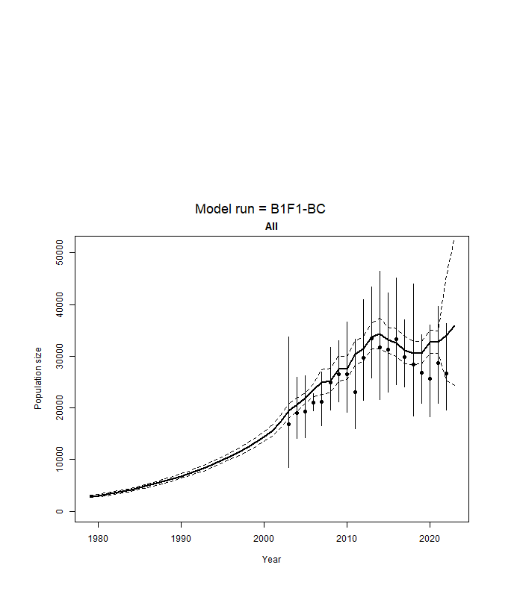
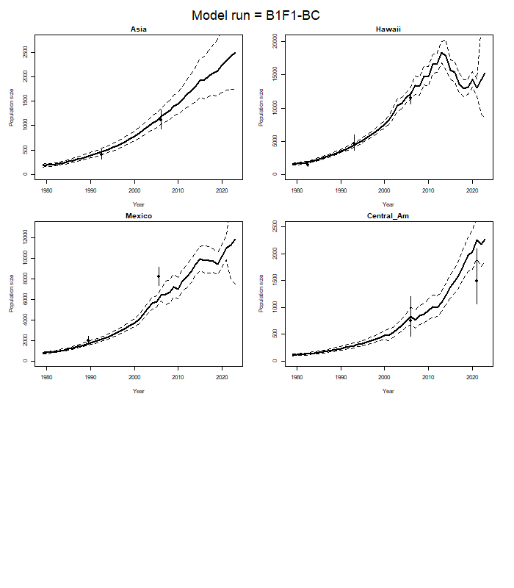
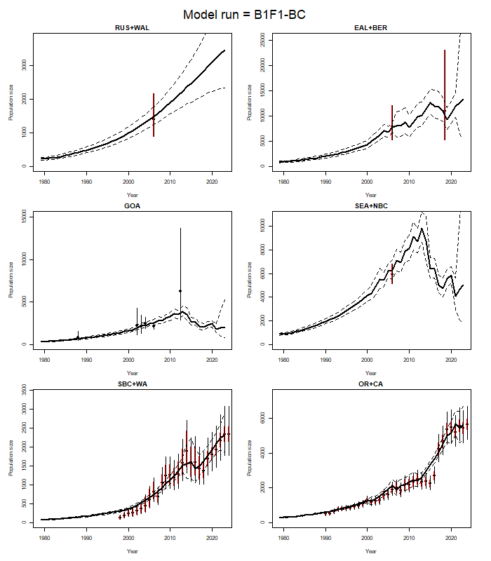
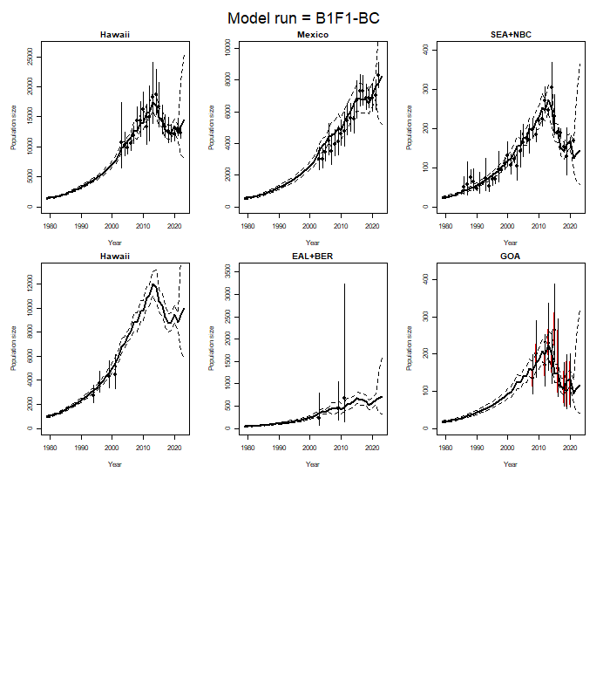
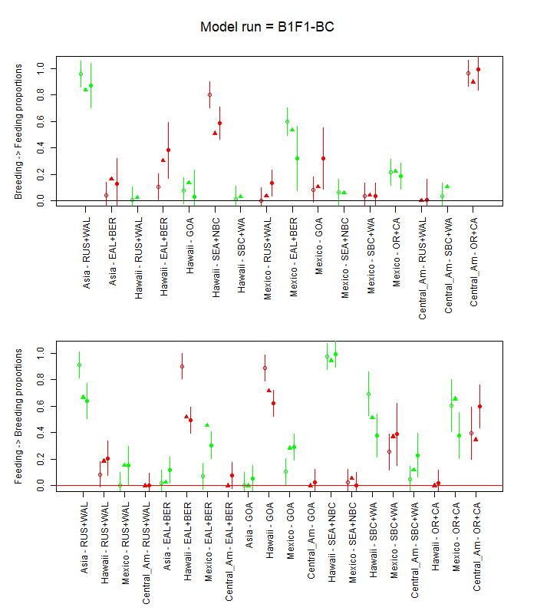
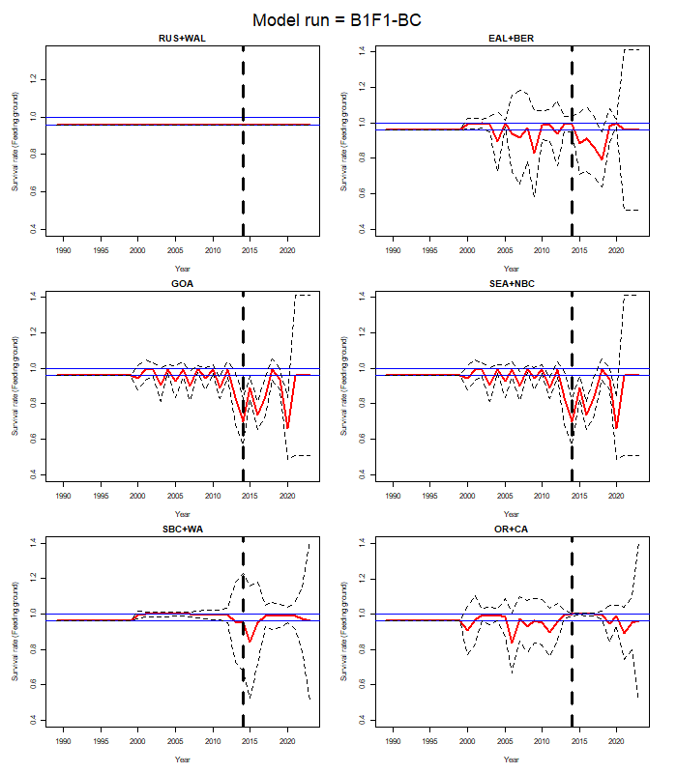

Figure 2: Stock hypothesis B1-F2
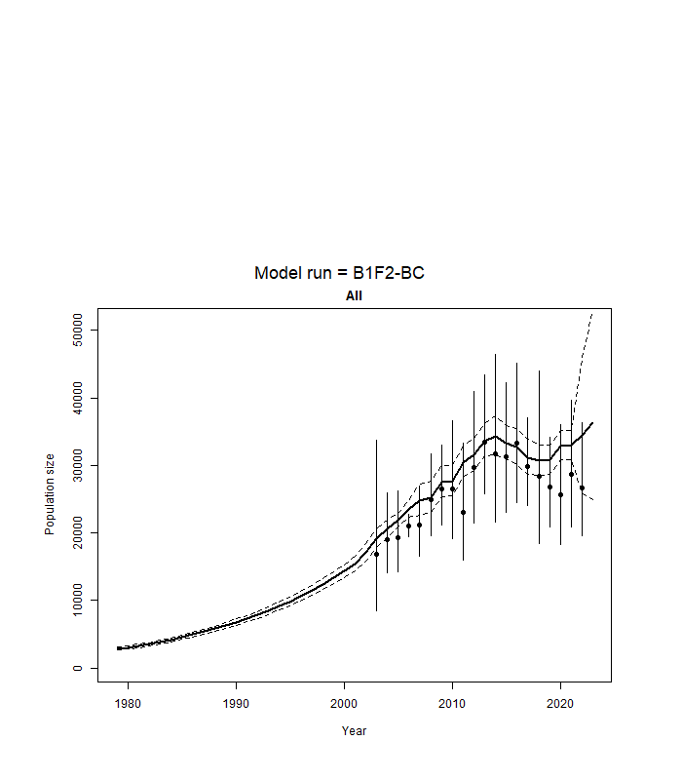
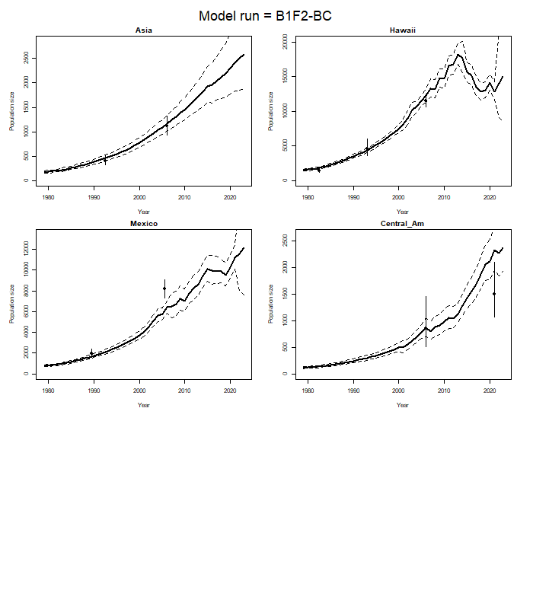
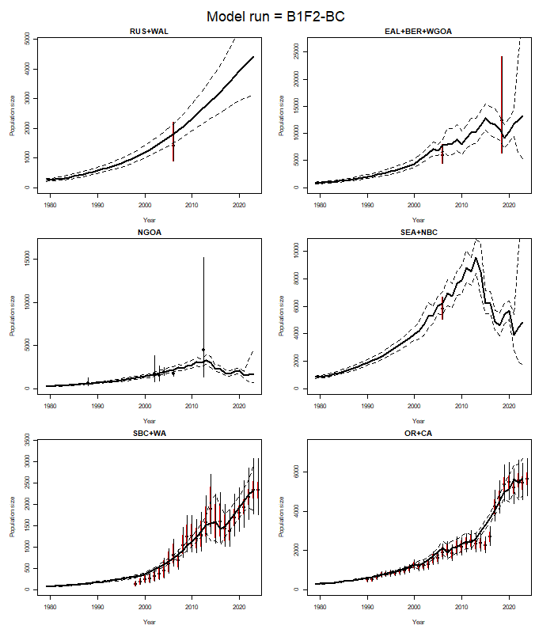
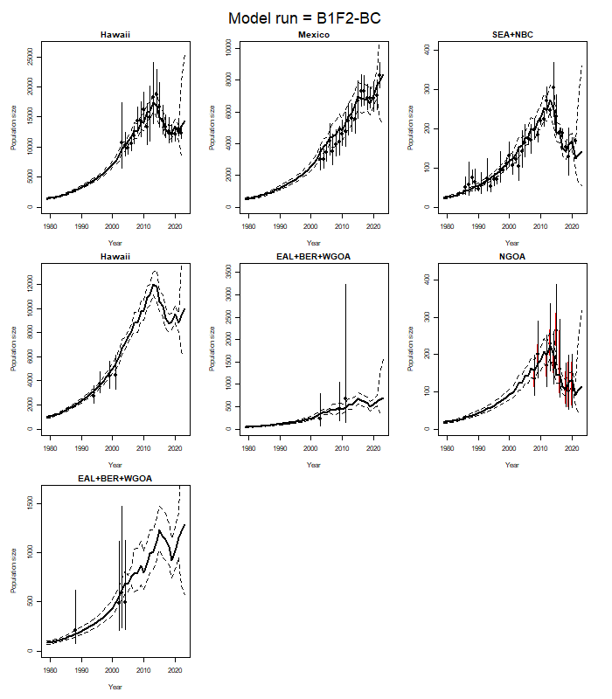
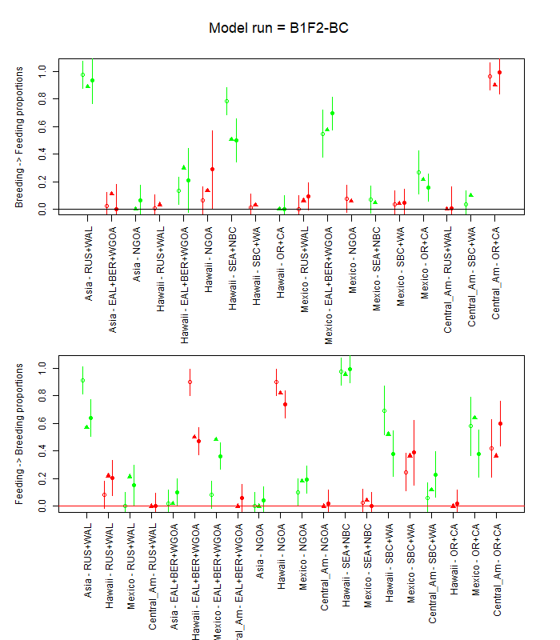
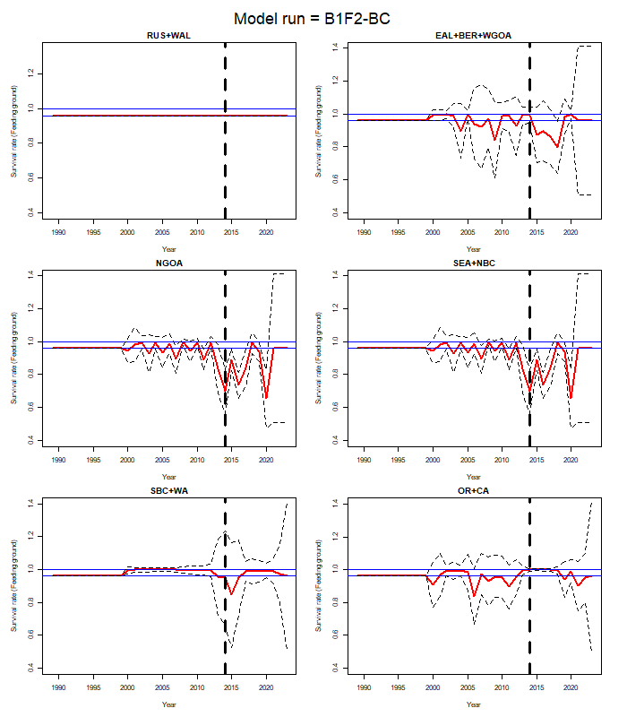

Figure 3: Stock hypothesis B2-F1
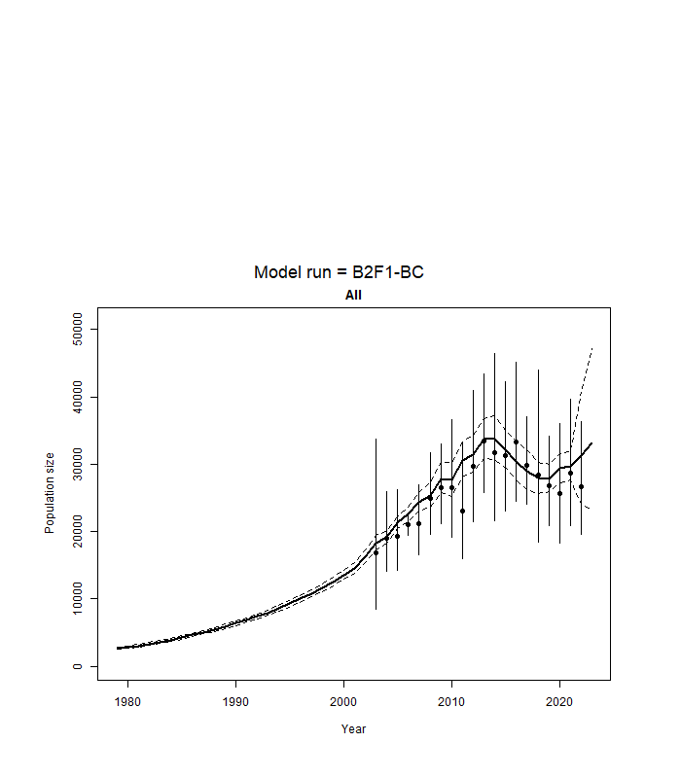
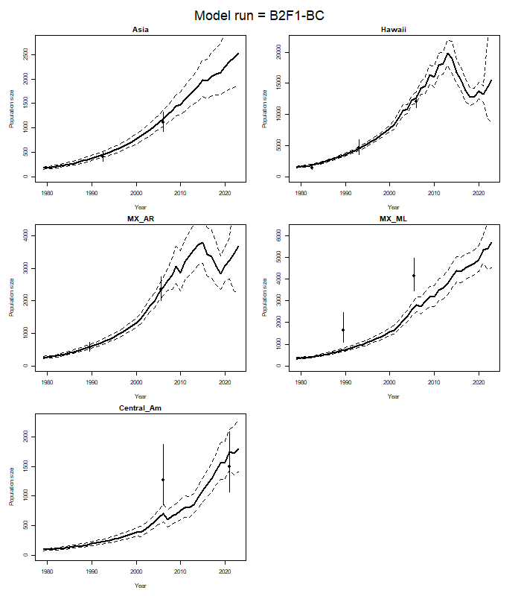
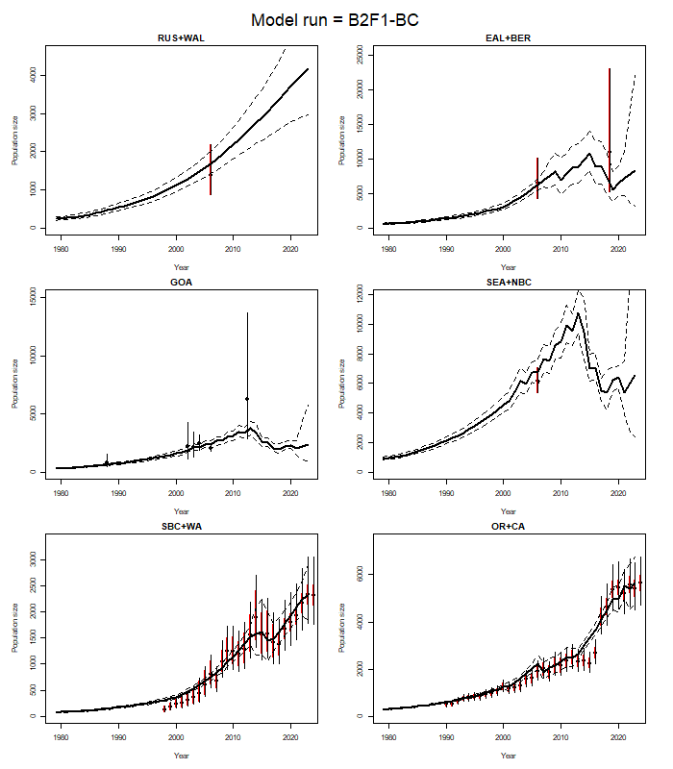
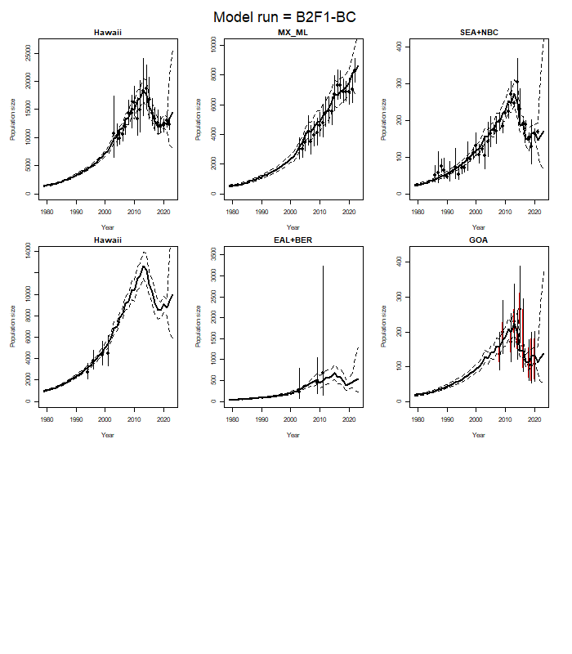
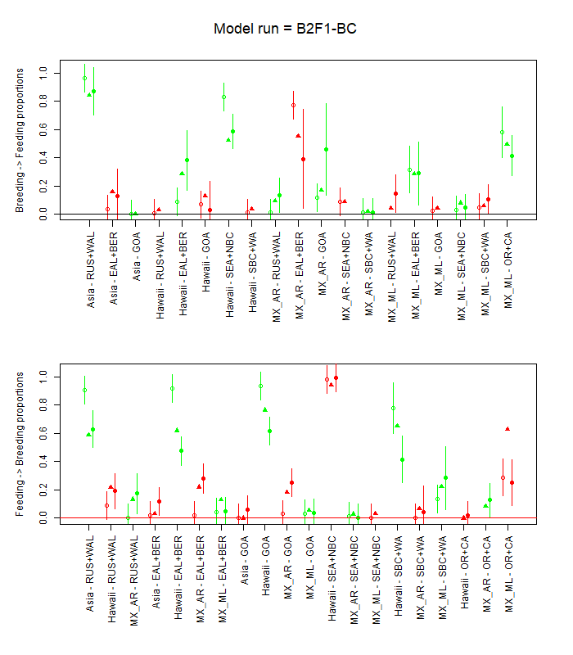
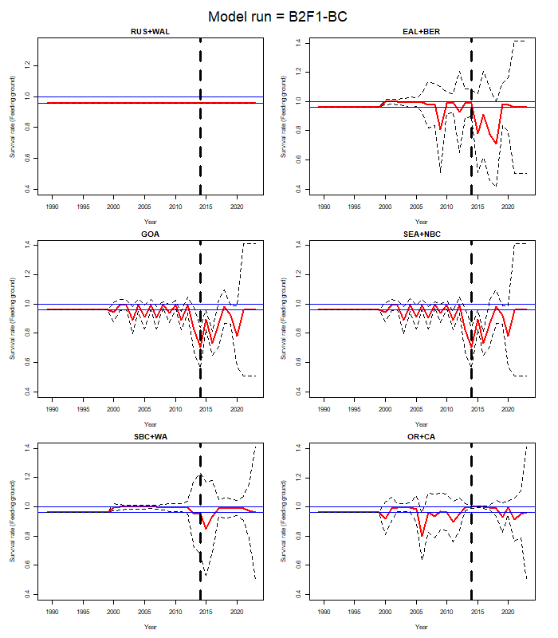

Figure 4: Stock hypothesis B2-F2
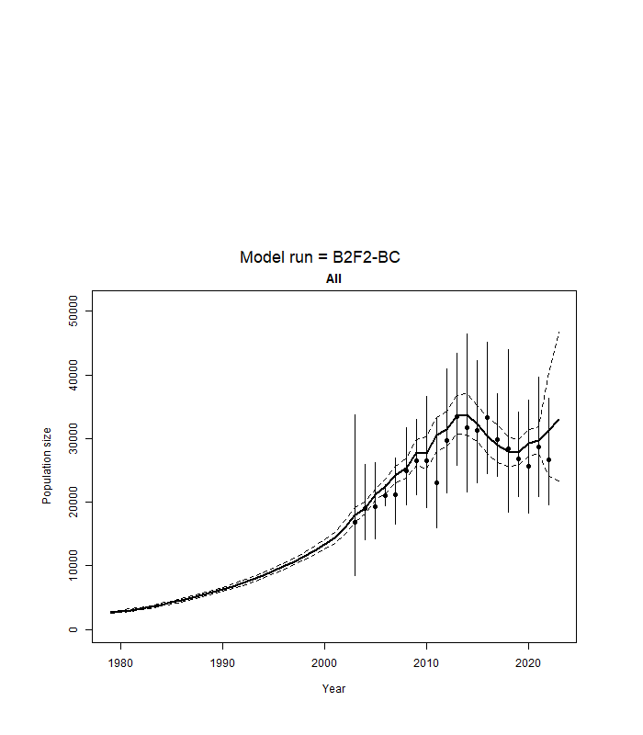
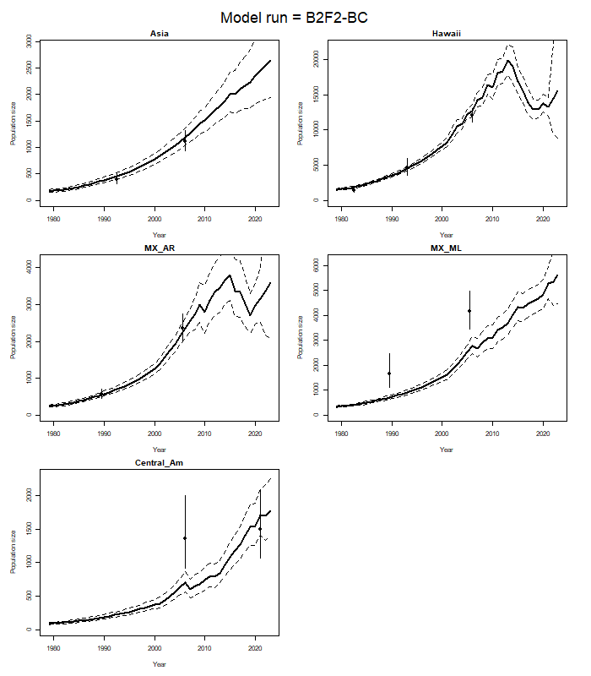
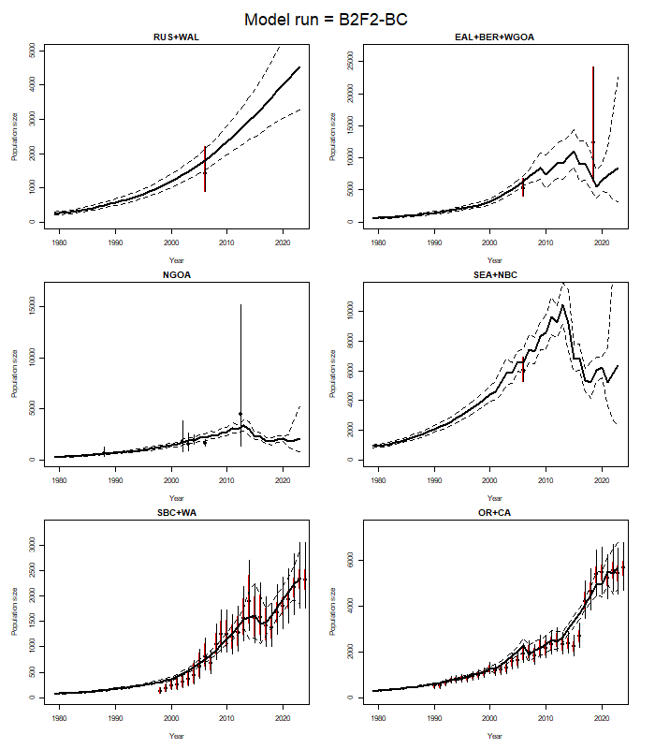
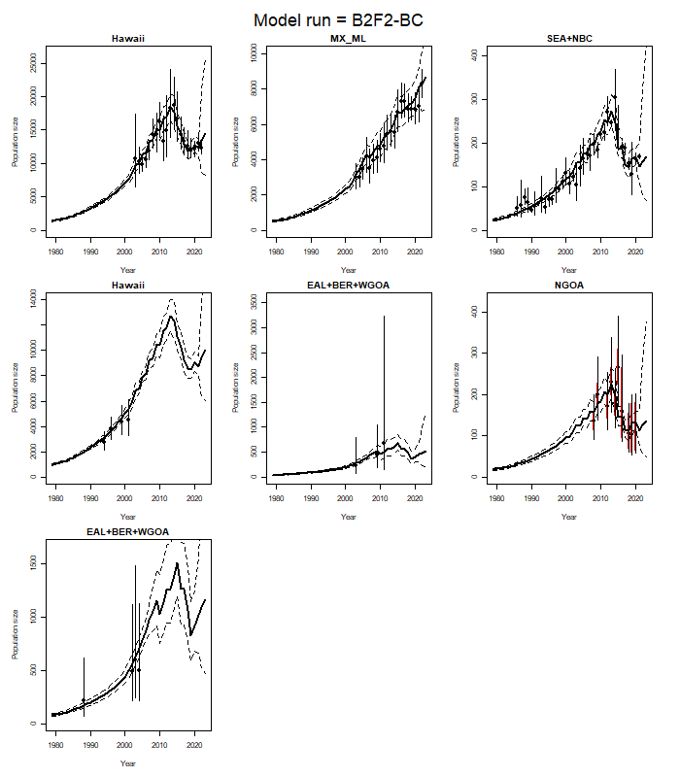
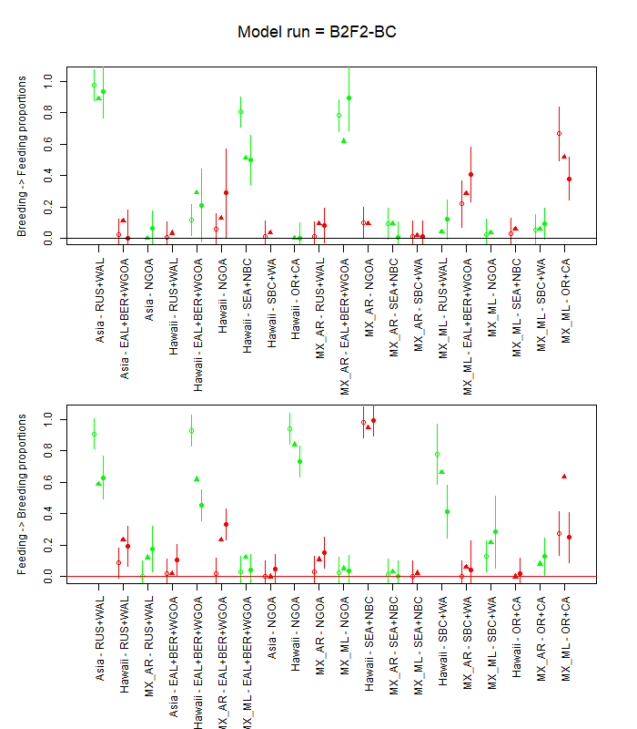
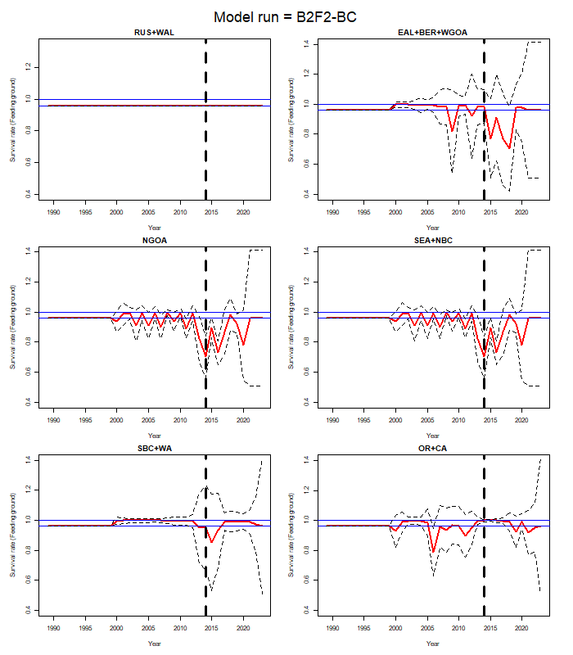

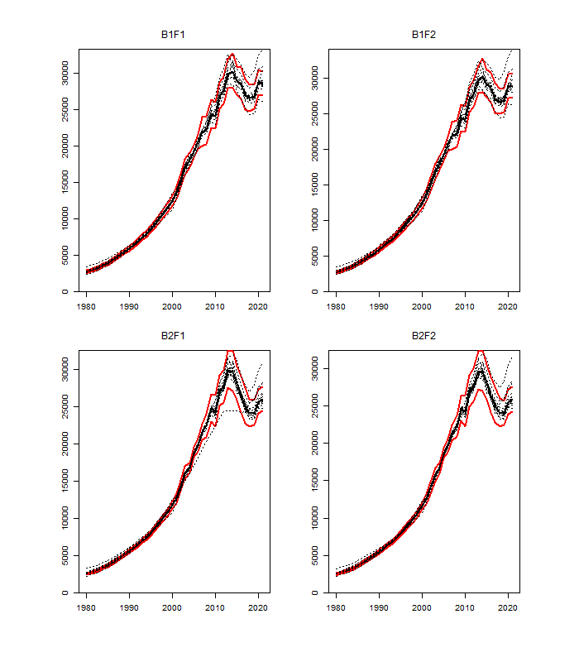
Figure 5. Sensitivity of the time-trajectories of total abundance to varying the factors in Table D.2. The solid line is the base-case model and the red lines indicate 95% asymptotic confidence intervals for the base-case model.

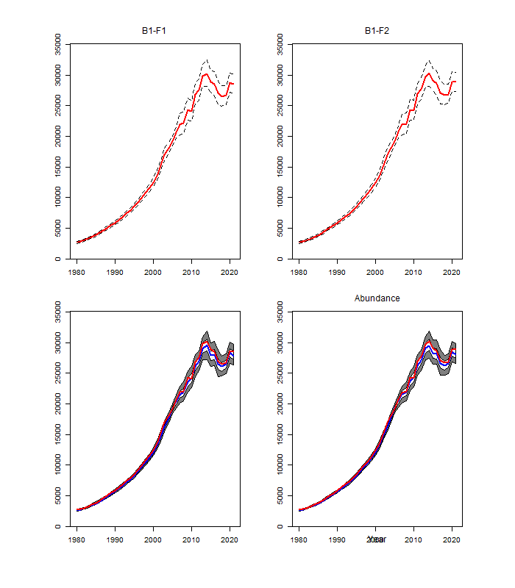Figure 6. Model estimates of absolute abundance for the entire North Pacific with their 90% confidence intervals. Results are shown in the upper panel based on the asymptotic approximation and in the lower panel based on the bootstrap procedure. The light shaded area in the lower panel covers 50% of the distribution.

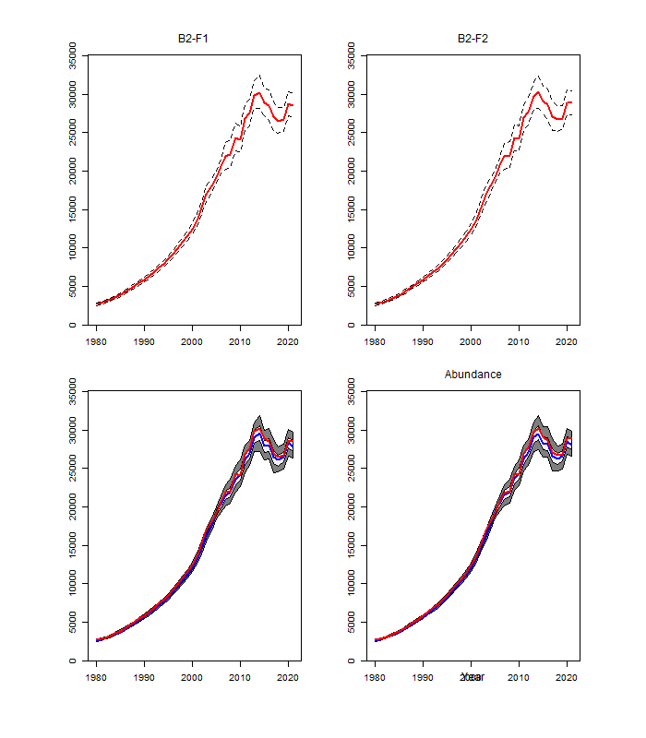Figure 6 Continued)

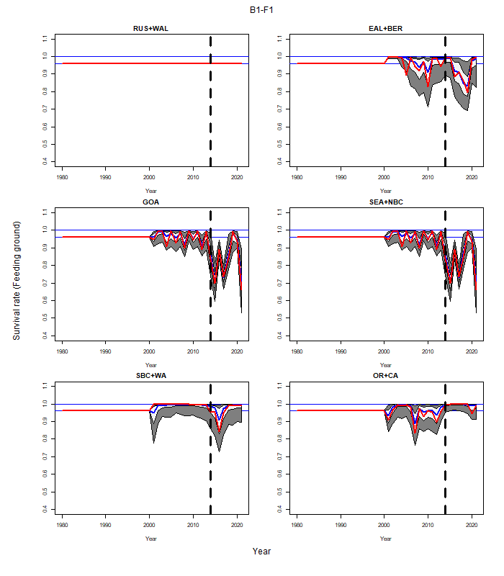Figure 7. Time-trajectories of model estimates (with asymptotic 90% confidence intervals) of natural survival by feeding ground from the base-case version of the model for the each of the stock structure / spatial hypotheses. Note that no allowance is made for time-variation in survival for the RUS+WAL feeding ground and the survival rates for the GOA feeding ground is “mirrored” to that of the SEA+NBC feeding ground.

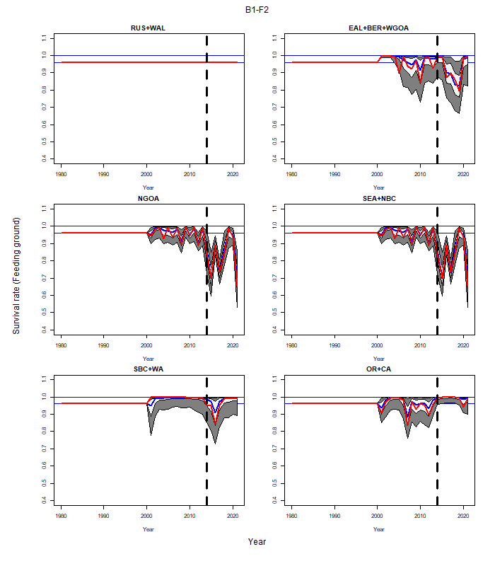(Figure 7 Continued)

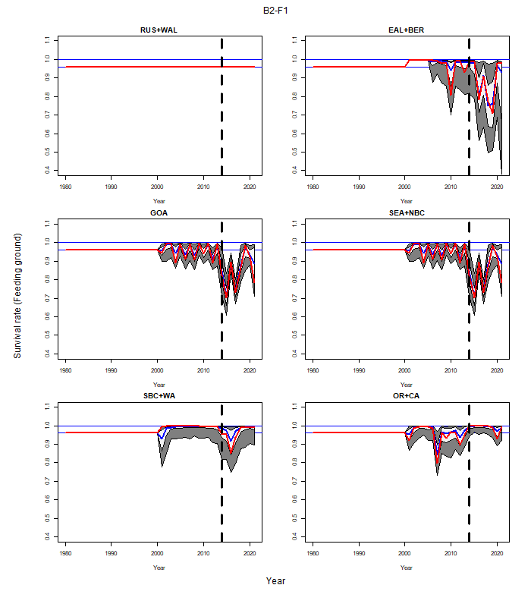(Figure 7 Continued)

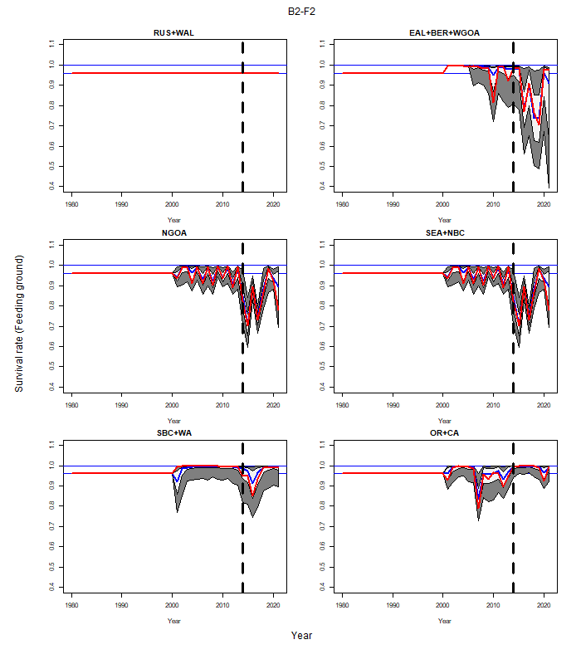(Figure 7 Continued)

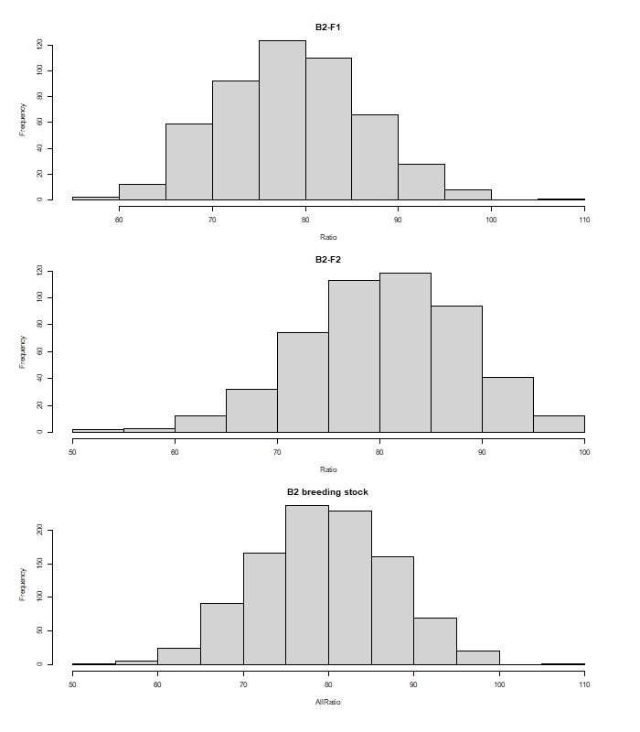Figure 8. Histograms of the change in total abundance from 2002 to 2021 for the base-case model fits based on the B2 stock-structure hypothesis.

This is the key output compared among sensitivity tests.

